SAFECROSS

**INTRODUCTION**

The Accessible Safe Crossing App project aims to improve the safety and mobility of urban pedestrians, especially those with impaired or limited mobility. By using comprehensive user research, advanced technology, and real-time data integration, the app will offer essential features such as GPS-based location detection, route planning, voice guidance, and real-time traffic updates. This project aims to fill the important need for accessible navigation tools, ensuring that all pedestrians can travel through urban areas safely and confidently.

**PROBLEM STATEMENT**

In urban areas, pedestrians, especially those with impaired mobility, encounter significant safety obstacles due to the absence of accessible crossing apps. Insufficient infrastructure, such as inadequate pedestrian signals and inaccessible curb cuts, makes navigation challenging for individuals with disabilities. Existing pedestrian crossing apps often lack essential features like audio cues, vibration alerts, and detailed, accessible maps. This technology gap, coupled with the absence of real-time traffic data integration, heightens the risk of accidents for these individuals. Moreover, current apps are often not user-friendly or customizable for people with disabilities, further compounding the problem. Addressing these challenges requires improvements in urban infrastructure, the development of inclusive technologies, and rigorous enforcement of accessibility standards.

**PROPOSED SOLUTION**

In order to create a user-friendly and secure pedestrian crossing app designed for urban areas, with a focus on individuals with impaired or limited mobility, the process commences with in-depth user research using surveys, interviews, and observations to comprehend their specific requirements and obstacles. Subsequently, the requirements and features of the application are established based on this research, ensuring that they offer effective solutions such as audio cues, vibration alerts, and accessible maps. Following this, a prototype design is developed to visualize the app’s layout, navigation flow, and key features, allowing for feedback and refinements. The technology selection process involves selecting an appropriate technology stack that supports the app's functionality and accessibility requirements. During the development phase, crucial functionalities such as GPS-based location detection, route planning, and voice guidance are integrated and thoroughly tested. Real-time integration includes the incorporation of APIs for traffic updates and pedestrian signals to provide accurate and up-to-date information. The launch and deployment phase encompasses optimizing performance, implementing robust security measures, and ensuring compliance with app store guidelines for public access. Finally, continuous improvements are made by monitoring user feedback and app performance post-launch, enabling ongoing enhancements and updates.

**FLOW OF THE PROJECT**

**1ST PAGE 2ND PAGE: LOGIN**

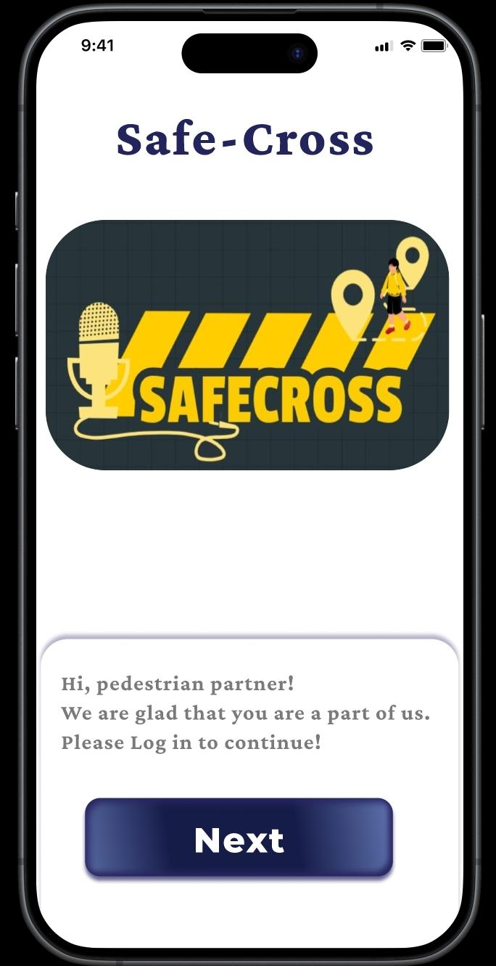 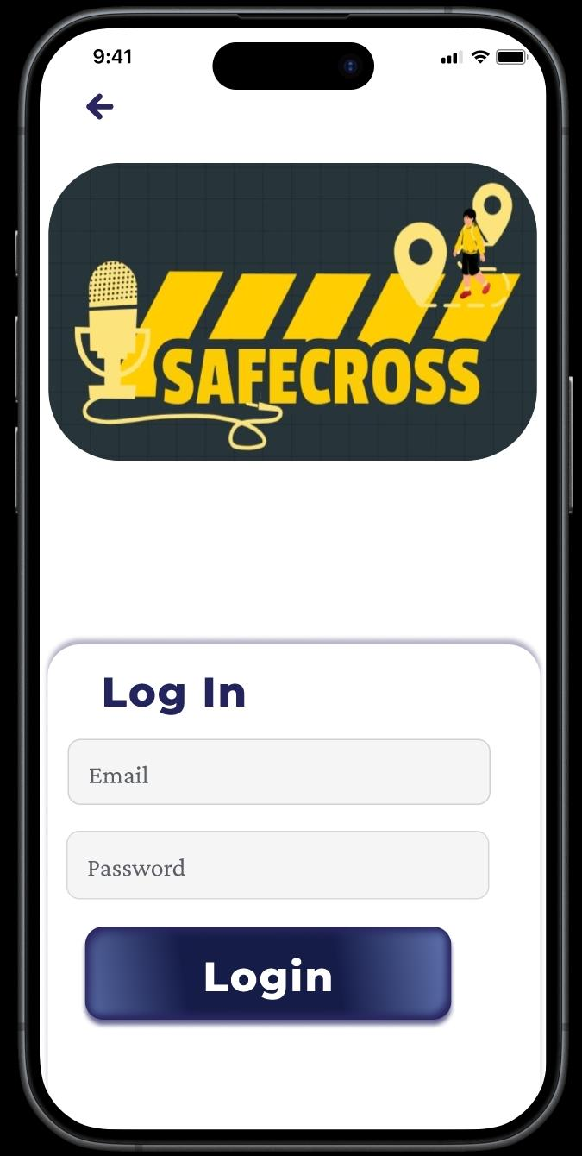

**3RD PAGE: 4TH PAGE:**

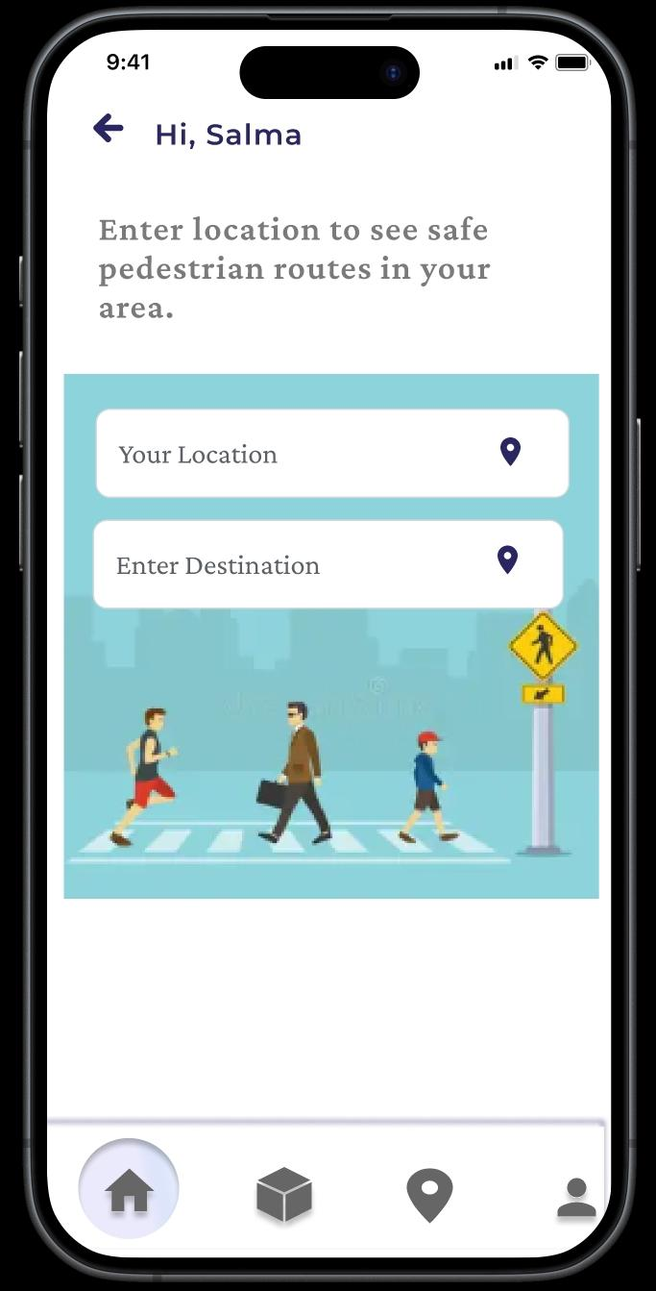 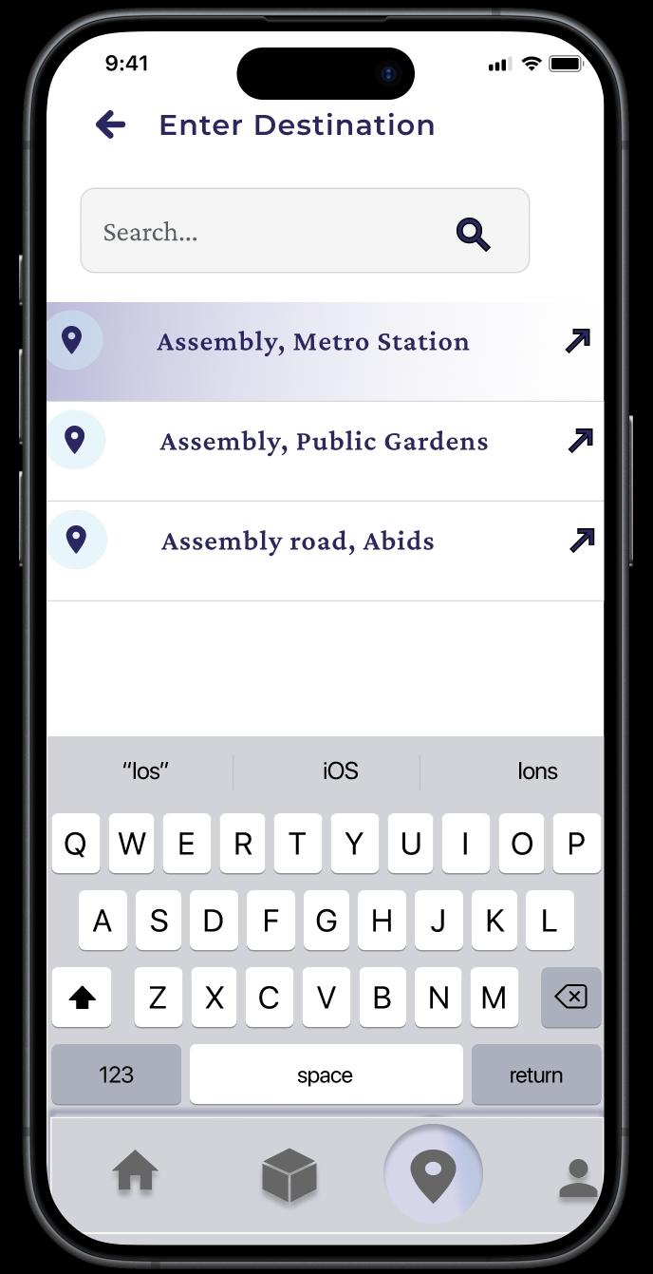

The user is required to input the current location and the destination location in order for the map to provide the most convenient route.

**5TH PAGE**: 6TH PAGE:

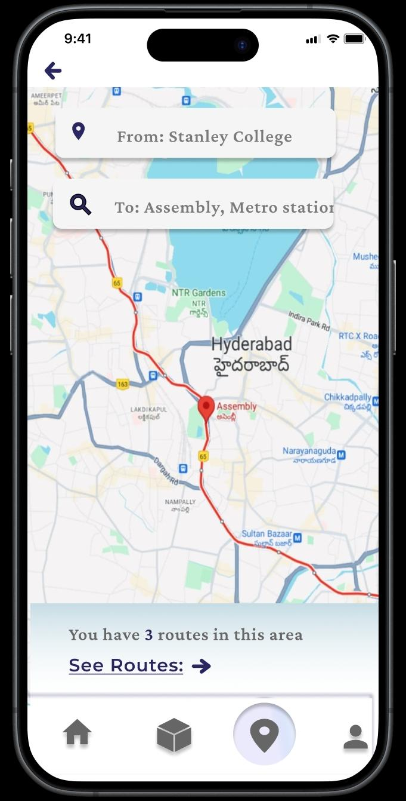 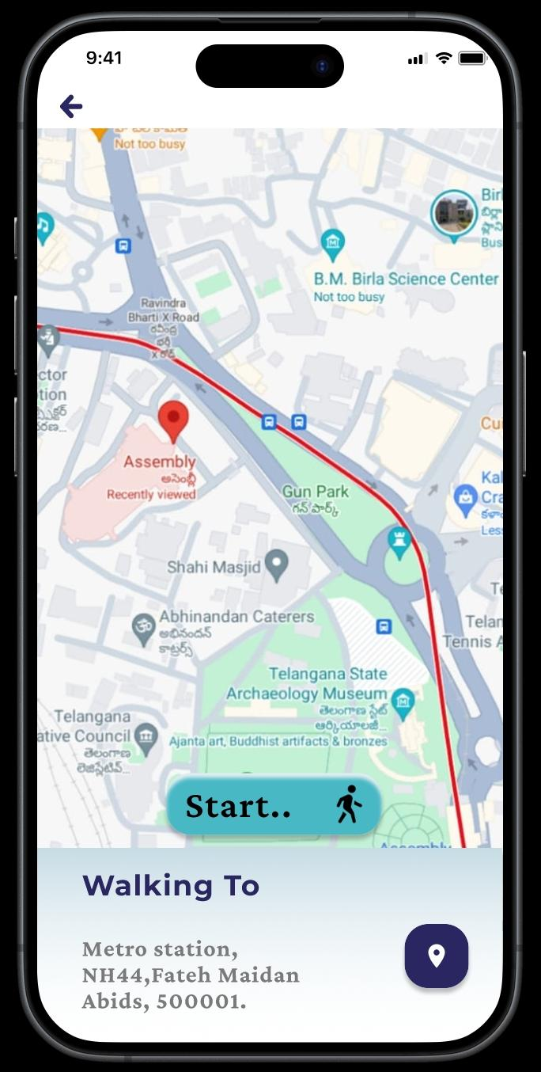

This app shows the different possible ways to reach the destination

**7TH PAGE: 8TH PAGE:**

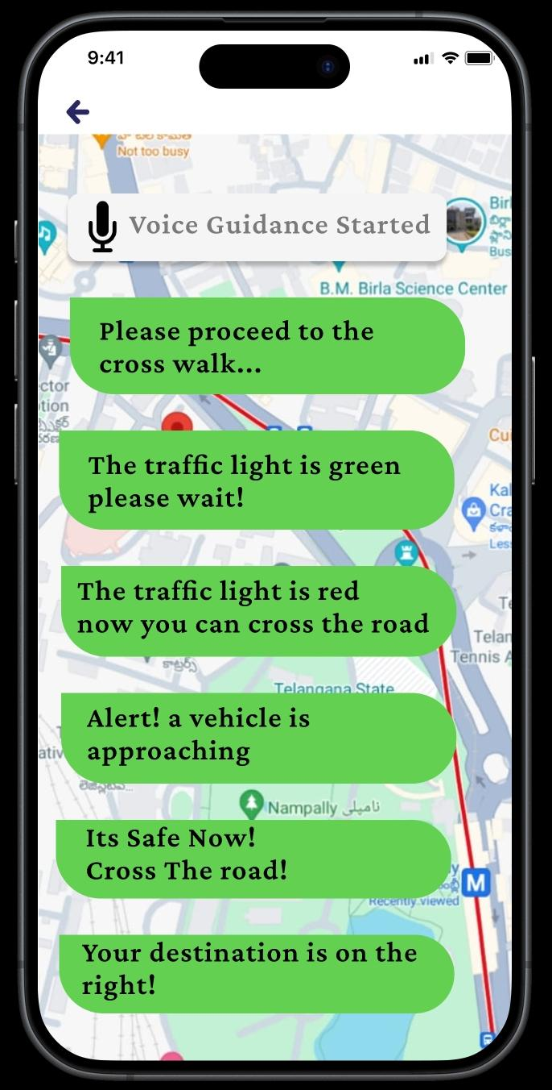 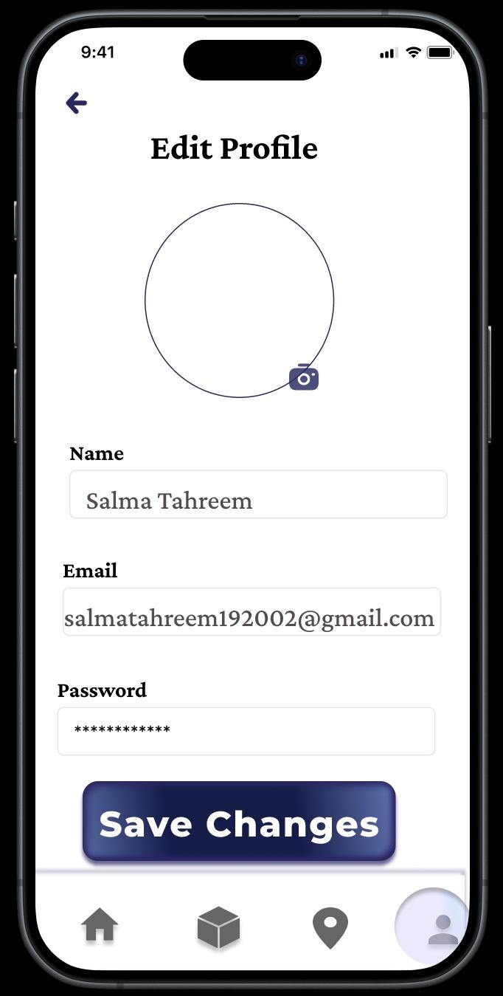

"This app will feature a voice assistant to help users easily access their desired route."

